Final Report: Inventory Management System

Deon Hill, Leeshaun Horne, Travis Ryan, and Tyler Traudt

Department of Computer Science, University of Maryland Global Campus

CMSC 495: Current Trends and Projects in Computer Science

Professor Rabiha Kayed

December 13, 2021

**Final Report: Inventory Management System**

**Overview:**

Inventory Management Systems are essential to the daily operations of many organizations. The primary goal of inventory management is to assist businesses to conveniently and efficiently manage the ordering, stocking, storing, and using of supplies. The intent of the correct management of inventory is a fundamental pillar of achieving success in enterprises because it ensures that stocks of raw material or other supplies are maintained at levels that provide maximum service levels at minimum costs. The application consists of a graphical user interface (GUI) and data saved into a structured query language (SQL) database. The application has a login screen in which the user will sign in and have access to a menu of options to choose from. Once logged in the user can choose to add/remove/modify products to the inventory, customer orders, employee information, or pull reports for management purposes.

**Project Plan**

WEEK 2:

* Have a plan in place for what the application will do and the specifications required to run the application.
* Define roles for different members of the project and different milestones we need to accomplish.

WEEK 3:

* Complete the user’s guide and test plan for the application.
* Create the basic GUI design for the application.

WEEK 4:

* Work on getting the SQL database operational and functional for the application.
* Complete project design for the application.

WEEK 5:

* Work on coding features into the product and employee selections of the application such as adding, editing, and deleting information from the database.
* Fully integrate the database with the application.

WEEK 6:

* Continue working on the code around features of the project and start working on reports selection in the application.

WEEK 7:

* Start to finish all features included in the application and add any other features that may be needed for user convenience.
* Test the application to find any bugs or errors and remedy them as they are found.

WEEK 8:

* Finish the application and perform quality checks to ensure all features work as intended.
* Complete any documentation that is required and turn in final project.

**Requirements Specification:**

* Requires java to be installed onto the machine in order to run the application.
* The application needs all required libraries to be present in the same folder to include commons-dbcp2-2.9.0, commons-logging-1.2, commons–pool2–2.11.1, jBCrypt-0.4.1, and mysql-connector-java-8.0.27.

**System Specification:**.

* This application should be able to run on any modern computer.
* The application will need a connection to the internet to run.

**User Guide**

As mentioned previously, the application will have a GUI interface for the user with menu options for inventory management**.**

Home Screen

When the program is executed, a login page will appear where the user will need to provide the correct credentials in order to access the application.

*To register*

* If a user is not registered then they will need to be added to the employees table by a manager on the employees page in the application. Once the employee is added to the table the manager will then be able to click the employee on the table and click the “Create Account” button. Once the button is clicked the employee will need to create a username and password that they will use to log in to the application for the future.
* The manager can delete the employees account by clicking the employee and deleting them from the employees table. The manager can also delete the account by clicking the “Delete Account” button and entering the username they would like to delete.

*To Log In*

* Once you run the application a login menu will appear in which a user can enter their username and password. If the user already has an account and enters the correct username and password they will be able to log into the application.
* Once you have successfully logged in, if you have the employee role you will be able to access the Products menu option and the Orders menu option. If the user has the manager role they will be able to access all features of the application.

*Viewing and searching products*

* Click the “Products” menu option. This will open the Product Inventory form. On the form, you will see all products in the inventory displayed. You will also be able to search for a product by typing in the name of the product and clicking the “Search button”. To refresh the form, click “Reset”.

*Adding, Modifying, and Deleting products*

* On the Product Inventory Form, you will see buttons for selection to “Add Product”, “Modify Product”, “Delete Product”.
* To add a product, click the “Add Product” button. A form will show up for you to enter information concerning the product including Category, Name, Quantify, Price, Description, and In stock or out of stock. Click “Add” to add the product to the inventory or “Cancel” to cancel. Ensure you click the “Reset” button to see if the product has been successfully added.
* To edit a product, click the “Modify Product” button. A form will show up for you auto-populated with the product including Category, Name, Quantify, Price, and Description. Modify the auto-populated information as you wish. Click “Modify” to edit the product to the inventory or “Cancel” to cancel. Ensure you click the “Reset” button to see if the product has been successfully modified.
* To remove a product from the inventory, select the product you wish to delete on the Product Inventory Form and the “Delete Product” button. Ensure you click the “Reset” button to see if the product has been successfully deleted.

*Orders*

* Click on the “Orders” menu option to add order information.
  + Enter the Customer information and select the type of payment they will be using and click the “Start Order” button. This will allow you to start adding products to the current order. Click the “End Order” button once finished.
  + A form will show for the user to input the product name, the number of products sold, and the price the products sold for.
  + Remove orders from the table by clicking the “delete orders” button on the form after selecting on the table the order you would like to delete.

*Adding and Modifying Employee’s Information (For Managers only)*

* Click on the “Employee” tab to add, modify, or delete employee information.
  + Add Employee by entering the required information and clicking the “Add Button”
  + Modify an employee’s information by selecting the employee from the table and editing the desired information that automatically sets to the text fields. Click the “Modify” button.
  + Remove an employee’s information from the system by selecting that employee from the table and clicking the “Delete” button.

*Running Reports for product, order, and employees data (For Managers only)*

* Click on the “Reports” tab to run reports for products, orders, and employees.
  + From the drop-down select type of report.
  + Then click the run button.
  + A pop-up containing the report will be generated.

*Exiting or Logging Out of the Application*

* To exit the inventory management system application, click the red “X” at the top right hand of the Frame. You can also go to the main menu and select “File” at the top left corner and then click “Exit”. Lastly, you can use the shortcut of “Alt + F4” to exit the application.
* To logout of the application you can select the Logged in: “Username” at the top right corner of the main menu. Once you select your account you can select the “Logout” option to go back to the login screen to use another account. You can also select your account and select “Change Username” to change your username or select “Change Password” to change your password.

**Test Plan**

**Test Case 1**

|  |  |  |  |
| --- | --- | --- | --- |
| **Input** | **Expected Output** | **Output** | **Results** |
| Manager goes to employees page, selects the employee they want to create an account for, and then click “Create Account”. User will then enter their account information. | Manager should receive a pop-up annotating that the account has been successfully created. |  | **Pass** |

**Test Case 2**

|  |  |  |  |
| --- | --- | --- | --- |
| **Input** | **Expected Output** | **Output** | **Results** |
| Users enter their username and password when logging into the application. (User is an manager) | The user should be able to use the employee tab and reports tab in the application. |  | **Pass** |

**Test Case 3**

|  |  |  |  |
| --- | --- | --- | --- |
| **Input** | **Expected Output** | **Output** | **Results** |
| Users enter username and password when logging into the application. (User is an Employee) | The user should not be able to use the employee tab or the reports tab. |  | **Pass** |

**Test Case 4**

|  |  |  |  |
| --- | --- | --- | --- |
| **Input** | **Expected Output** | **Output** | **Results** |
| User clicks the “Product” tab and searches for a product by typing in the name of the product and selecting the “Search” button | The Product Inventory page should load and products in the inventory should be displayed. The user should be able to type in the name of the product and click search. The product the user searched for should be displayed. |  | **Pass** |

**Test Case 5**

|  |  |  |  |
| --- | --- | --- | --- |
| **Input** | **Expected Output** | **Output** | **Results** |
| User clicks the “Add Product” button on the Product Inventory page after entering all the product information. | The user should then receive a message that the product has been added and the product should be displayed on the table to the right. |  | **Pass** |

**Test Case 6**

|  |  |  |  |
| --- | --- | --- | --- |
| **Input** | **Expected Output** | **Output** | **Results** |
| User clicks a product from the table on the Product Inventory page “Modify Product” button | A form should show up with the information for the product auto-populated in the text fields. The user should then be able to edit the information as they see fit and should then be able to click “Modify”. After the user makes a modification the product will display the modified information on the table. |  | **Pass** |

**Test Case 7**

|  |  |  |  |
| --- | --- | --- | --- |
| **Input** | **Expected Output** | **Output** | **Results** |
| User clicks a product from the table on the Product Inventory page “Delete Product” button. | The user should receive a message that the product has then been deleted and then be brought back to the Product Inventory Form. The product will then be removed from the table. |  | **Pass** |

**Test Case 8**

|  |  |  |  |
| --- | --- | --- | --- |
| **Input** | **Expected Output** | **Output** | **Results** |
| User does not select a product and clicks the “Modify Product” or “Delete Product” button | The user should receive an error message stating that they need to select a product to modify/delete |  | **Pass** |

**Test Case 9**

|  |  |  |  |
| --- | --- | --- | --- |
| **Input** | **Expected Output** | **Output** | **Results** |
| User enters incorrect username and or password | The user should receive an error message stating that the username or password is invalid |  | **Pass** |

**Test Case 10**

|  |  |  |  |
| --- | --- | --- | --- |
| **Input** | **Expected Output** | **Output** | **Results** |
| User enters the name of a product that is already inside the inventory. | The user should receive an error message stating that the product is a duplicate in the inventory. |  | **Pass** |

**Test Case 11**

|  |  |  |  |
| --- | --- | --- | --- |
| **Input** | **Expected Output** | **Output** | **Results** |
| User clicks on the reports tab (User is a manager) The user will be able to run reports on the product, order, and employees data. | Users will get information about the total cost of operations from running these reports. |  | **Pass** |

**Design**

**Application Diagram:**

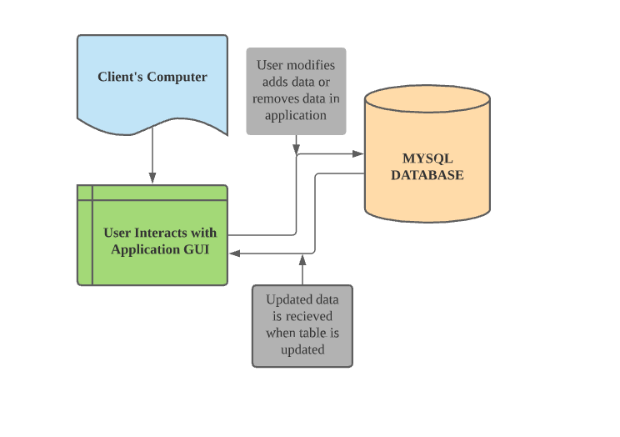

**UML Diagram of Application:**

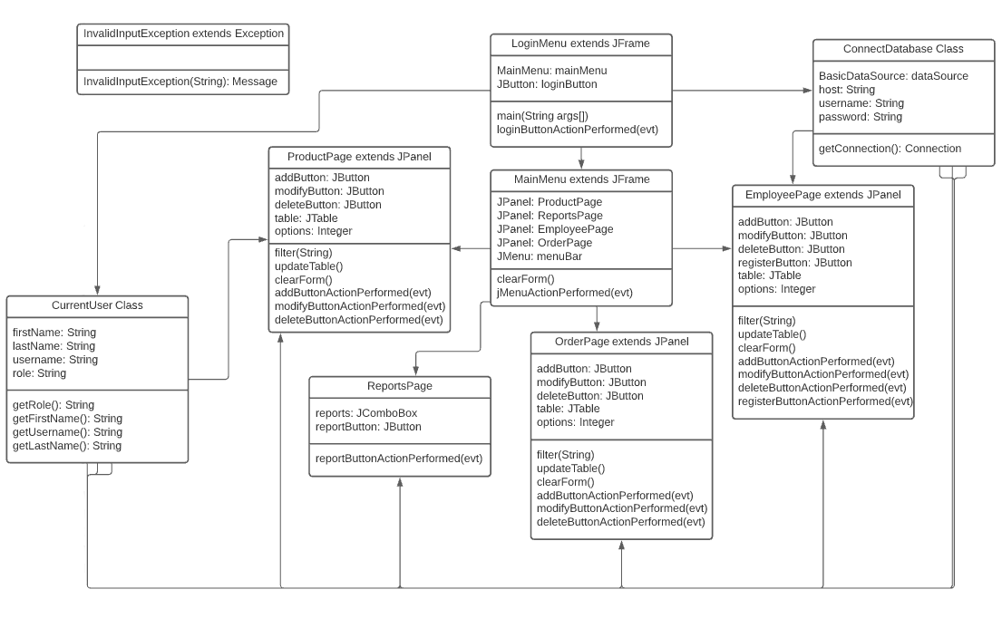

*Key Features:*

* Ability to create accounts
* Role-based access
* Add, modify, search, and delete product/order/employee information from the database.
* Table for user to see all data in the database
* Login/logout functionality
* Ability to change user password
* Manager is able to pull reports for an overview of data

*Main User Activities*:

1. If a user is an employee they will have access to add, modify, delete data from the products or order database. They will achieve this by clicking buttons and inputting data into text fields. Employees will have access to search the table for products or orders and reset the table to the original view. Employees will be able to select table rows and delete or modify them as necessary.
2. If a user is a manager then they will have access to every feature an employee has access to. Managers will be able to add new employees into the database to keep track of every employee working at the company. Managers will also be able to create accounts by searching for the employee they want to create an account for, clicking that employee row on the table, and then click the register button. Managers will also have access to generate reports for total product revenue, total employee salaries, and more.

*Subsystems:*

The application will work by interacting with a SQL database to store the data that the user inputs and make modifications to the data. The system will connect to the database using a connection pool class. This class will create a pool of connections ready to be used when a thread needs them to increase the performance of the application while decreasing the number of resources the application will need to use. After a connection object is done being used, then it will be released back into the connection pool for the next thread that needs access to a connection. There will be a total of four tables in the database being Products, Orders, LoginInfo, and Employees.

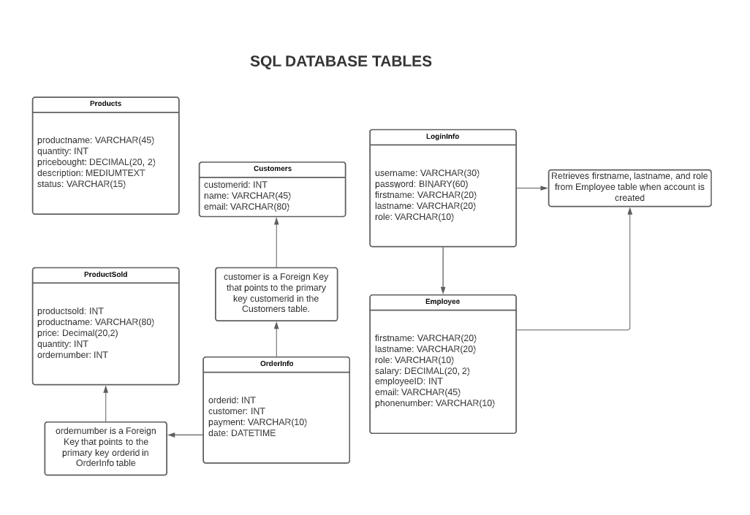

*Application Requirements:*

1. A SQL database server
2. Five java libraries are required for the application to run. These are commons-dbcp2-2.9.0.jar, commons-logging-1.2, commons-pool2-2.11.1, jBCrypt-0.4.1, and mysql-connector-java-8.0.27.
3. The application jar file

**Design Considerations:**

*Operational Environment:*

For this application, we will mainly be working in a Java IDE. Our group will be sharing important documents and the latest coding updates through a google drive shared folder. We will be discussing updates and progress on the application through weekly meetings on a discord server.

*Development Methods:*

We will be creating the GUI interface for the user using java’s swing library. The application will connect to the database using a database connection pool class to open and close connections as they are needed. The current logged-in user will be stored in the current user class after the user has logged into the application. The table presented to the user will be constantly updated every time a user makes a change to the database.

*GUI Layout:*

The user will first be presented with a login page where they will enter their username and password. Once a user is logged in successfully they will be presented with the main menu of the application. From here they will be able to navigate to the Products or Orders pages. If the user is a manager then they will have the option to also navigate to the Employees and Reports pages. There will be a menu bar at the top of the main menu with the current logged-on user being displayed. The user will be able to click on the current logged-on user and a drop-down will appear to change their password or log out of the application. There will also be an option to exit the application on the menu bar.

**Phase 1 (Week 5 Progress):**

The first original milestone for the fifth week of class was to work on coding features into the product and employee selections of the application such as adding, editing, and deleting information from the database. The second milestone was to fully integrate the database with the application. I would say that for this week we are ahead of schedule for the original milestone. Although the employee page isn’t within our application yet, the product page is fully functioning and working how intended with all features. The add, editing, and deleting buttons for the employee’s page will be similar to the code in the products page. We decided to implement more features to the employee’s page which is the reason that it is not present in the application for this week. We have also successfully integrated the database and have an RDS server through amazon which is online and working with our application.

A decision we re-evaluated while creating the application was to include a login screen for users to log into the application. We felt a login screen would be important because of the personal information that employees will have in the database that we don’t want anyone to be able to view. We also decided that having role-based access will be an important feature to include in the application so that any employee in the company won’t be able to see other employees’ information or how much money they make.

A special problem that came up while making the login interface was the storing of passwords in plain text inside the database. We didn’t want to have the passwords stored in plain text, so we decided to implement a library called jBCrypt that is used for encrypting passwords before we stored them in the database. jBCrypt encrypts the password with salt and then our application stores it into the database as bytes. Our application will then pull the password out of the database, convert it to a string, and then use jBCrypt to unencrypt the password to check against the inputted user’s password. This also needs to be done when the user changes their password with the change password feature.

**Phase 2 (Week 6 Progress):**

For week six we originally planned to start working on the reports selection and continue working on different features and functionality on the application. We already started working on the report’s selection of the application last week and are continuing to work on it but haven’t added anything to that page for this week. We have added a functioning employee page where a user can add, modify, and delete employees in the database. We also changed the way that the main menu page looks. The employee page will still need to be changed to enable the creation of an account based on the employee information by adding a button called “create account”. We will also add some type of functionality to delete accounts as needed, but still need to work out the details of this feature.

**Phase 3 (Week 7 Progress):**

Our original goal for this week was to finish all features in the application and add any other features that may be needed for user convenience in addition to finding bugs or errors in the application and fixing them. What we worked on this week was still on track with our original goals, but because we decided to add more than what we originally discussed we are still working on getting the order page of the application to what we want it to be. We did add some additional features this week such as adding the option for a user to change their username after clicking their account at the top right of the main menu.

We also added the functionality for the creation of a user account on the employee page. The user can create an account for another user by clicking the employee on the table and then clicking the “Create Account” button. This will automatically pull information from the employee table such as the name, email, and role then it will ask the user to input a username and password. Once the username and password have been inputted then it will create an account for the user. We also added a button called “Delete Username” that can delete a user by entering the user’s username that you want to delete. Lastly, we added additional options on the report’s page so that the user can get the total amount of money spent or either employee, products, or both.